LOGO

Organisation [Name]
Department [Name]
<Requirements Management Plan>
<Project Name>
Date: <Date>
Doc. Version: <Version>

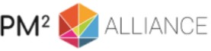

Template version: 3.0.1
This artefact template is aligned with the PM² Guide V3.0
For the latest version of the templates visit:
https://www.pm2alliance.eu/publications

The PM² Alliance is committed to the improvement of the PM² Methodology and of its supporting artefact. Project management best practices and community contributions & corrections are incorporated in the
PM² Alliance’s artefact templates.
Join the PM² Alliance and visit the PM² Alliance GitHub to provide your feedback & contribution: https://github.com/pm2alliance
Document Control Information

Settings | Value
Document Title: | Requirements Management Plan
Project Title: | <Project Name>
Document Author: | <Document Author>
Project Owner: | <Project Owner (PO)>
Project Manager: | <Project Manager (PM)>
Doc. Version: | <Version>
Sensitivity: | <Public, Basic, High>
Date: | <Date>

Document Approver(s) and Reviewer(s):
NOTE: All Approvers are required. Records of each approver must be maintained. All Reviewers in the list are considered required unless explicitly listed as Optional.
Name | Role | Action | Date
 |  | <Approve / Review>

Document history:
The Document Author is authorized to make the following types of changes to the document without requiring that the document be re-approved:
- Editorial, formatting, and spelling
- Clarification

To request a change to this document, contact the Document Author or Owner.
Changes to this document are summarized in the following table in reverse chronological order (latest version first).
Revision | Date | Created by | Short Description of Changes

Configuration Management: Document Location
The latest version of this controlled document is stored in <location>.

<These notes should be deleted in the final version :>

Notes for Templates:
- Text in <orange>: has to be defined.
- Text in <blue>: guidelines and how to use the Template. Should be deleted in the final version.
- Text in green: can be customised. Should be recoloured to black in the final version.
TABLE OF CONTENTS
1. Introduction 4
2. Requirements Management Objectives 4
3. Requirements Management process 4
4. The Requirements lifecycle 6
5. Requirement Management Roles and Responsibilities 7
6. Tools and Techniques 8
6.1. Requirements documentation 8
6.2. Requirements traceability matrix 9
7. Requirements change management 10
8. Related PM² Plans 10
Appendix 1: References and Related Documents 11

Introduction
The purpose of this document is to define the Requirement Management process for this project. More specifically, this document:
- Describes the requirement management process to be used for the project;
- Defines the roles and responsibilities related to requirements management;
- Specifies the methodology, standards, tools and techniques and templates used to support requirements management.

Requirements Management Objectives
Requirements Management is the process of gathering, documenting and validating requirements, and managing their implementation and change. It is a process that runs continuously throughout the project life cycle and relates to other project management processes, such as quality and change management.
The Requirements Management process can be tailored and customised to a project’s needs and can be documented either in a Requirements Management Plan (this document) or in the Project Handbook. Separate requirements documentation is used to specify, categorise and prioritise the requirements and to provide traceability (requirements traceability matrix). These can be standalone documents or an annex to the Project Charter or the Project Work Plan.
Note that managing changing requirements to configuration items (e.g. requirements documentation, the Project Work Plan and deliverables) is part of project change management and is therefore documented in the Project Change Management Plan.

Requirements Management process
<Please tailor the requirements management process if necessary (complete description or delete activities that are not applicable to the project.>
The PM² requirements management process defines the activities related to identifying, documenting, evaluating, prioritising, approving, validating requirements, and communicating the status of requirements to all relevant stakeholders.
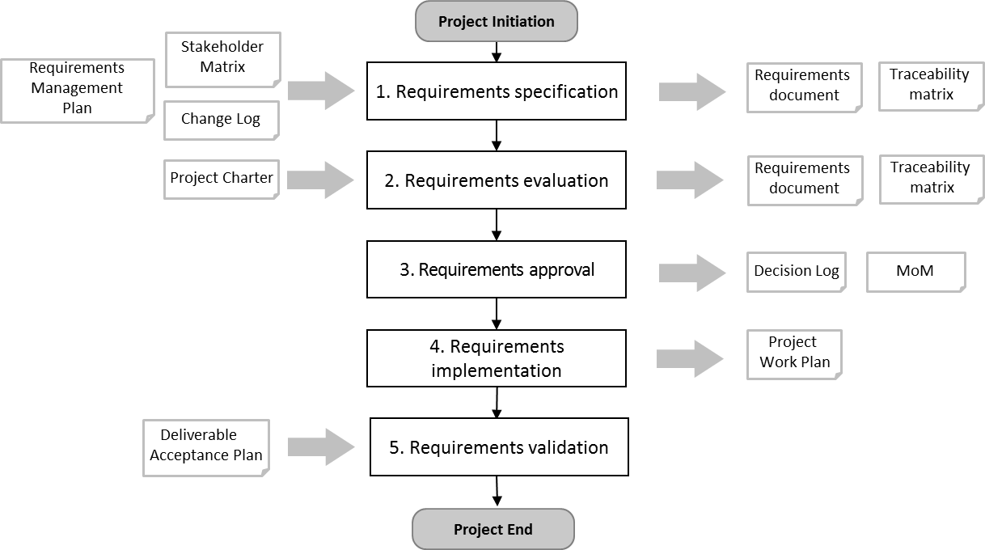
<If you tailor the process, make sure you align the above process diagram>
The requirements management process for this project is a five step process and falls under the responsibilities of the Project Manager (PM) who should execute the process when required throughout the project lifecycle:
Step 1: Specify the requirements
Together with the project stakeholders, gather the project requirements and document them clearly in the Requirements documentation. Structure them by adding relevant metadata. Many tools & Techniques can be applied here to gather requirements: brainstorming, nominal group technique, interviews, observation, story boards, prototyping, user stories, and more. Requirements can be documented using MS Word or Excel, or in a requirements documentation and management system.

It is crucial to identify and specify as many of the requirements as possible during planning. Discovering important requirements during execution might have a big impact on project cost and schedule.

In Agile projects the approach to requirements gathering is different from the more traditional (waterfall) project lifecycle. In Agile projects requirements are gradually discovered during the development of the deliverables. In an Agile project it is acceptable that requirements are removed, replaced or re-prioritised during the development.

Step 2: Evaluate the requirements
The project team assesses the feasibility, consistency and completeness of the requirements, and estimates the effort/costs needed to implement them. The Project Manager (PM) balances the list of requirements against project constraints (budget, time, etc.) and makes a proposal to the project stakeholders.

A requirement traceability matrix might be helpful to provide structure and traceability in extended requirements documentation, linking high-level business needs to detailed requirement, and detailed requirements to deliverables.

Prioritization of requirements is part of this step. Techniques like e.g. MoSCoW prioritisation can be applied. An important aspect of prioritisation is the relationship between requirements. Related and dependent requirements need to have the same priority.

The Project Manager (PM) verifies if requirements are in-scope as to the scope boundaries defined in the Project Charter. Requirements that are out-of-scope are logged as “not in scope” in or outside the Requirements documentation.

Any requirement should be testable on the deliverable(s). For this reason acceptance criteria are defined for each requirement. These criteria are part of the requirements documentation. These criteria are fundamental in the development of the deliverables as well as the test plans for final deliverable acceptance. See also step 5.

Step 3: Approve the requirements
The Project Manager (PM) and key stakeholders (such as the Project Owner (PO) or Business Manager (BM)) negotiate and agree on the requirements for the project and their priorities. In these negotiations the Project Manager (PM) makes sure that the in-scope requirements can be delivered given the cost and schedule boundaries set in the Project Charter.

The formal approval of the requirements documentation is logged in the Decision log and/or the minutes of the meeting (MoM), e.g. the Project Steering Committee (PSC).

Step 4: Monitor requirements implementation
The Project Manager (PM) continuously monitors the Project Core Team’s (PCT) implementation of the requirements, adds new requirements and changes existing ones where needed through formal change control. New and changed requirements need to follow the steps 1, 2 and 3 as described above. After approval the Project Work Plan (PWP) will be updated.

Step 5: Validate the implemented requirements
When the requirements are implemented, the deliverable is validated by the User Representatives (URs). They assess if the initial business need is satisfied. This validation is based on the acceptance criteria that are defined for each requirement (see step 2). Formal acceptance of the project deliverables should comply with the Deliverables Acceptance process as described in the Deliverable Acceptance Plan.

The Requirements lifecycle
A requirement may run through these lifecycle stages:
- Specified: The requirement is specified in a document or in a requirements documentation and management system.
- Proposed: The requirement has passed evaluation but not yet approved by the client. If it does not pass evaluation it will get status For Fixing or Rejected.
- Approved: The requirement is formally approved by the client. If it is not approved it will get status For Fixing or Rejected.
- Incorporated: The requirement is incorporated in the Project Work Plan (PWP). If during incorporation an issue is discovered the status may change into For Fixing.
- Implemented: The requirement is implemented in one or more of the project deliverables and tested against the acceptance criteria by the Project Core Team (PCT), but not yet formally accepted by the client. If during implementation an issue is discovered the status may change into For Fixing.
- Validated: The implemented requirement is formally validated against the acceptance criteria and accepted by the client. If during validation and acceptance an issue is discovered the requirements may be partially accepted and the status may change into For Fixing.
In addition, requirements may have these special statuses:
- For Fixing: If there is an issue, a requirement may get the status For Fixing at any stage of the requirements lifecycle. Reasons for this status may be that the requirement is not well documented or inconsistent with another requirement. Another reason is that the requirement did only partially pass validation. After resolving the issues a requirement may return to the status Specified. If an issue cannot be resolved a requirement may get the status Rejected.
- Rejected: A requirement may be Rejected for different reasons. Examples are: The requirement is obsolete, out of scope, not feasible, postponed (to a later project phase, or another project), merged with another requirement, and a requirement may be identified as a duplicate requirement and therefore rejected.

Requirement Management Roles and Responsibilities
The main roles and responsibilities for the requirements management process are:
- Project Owner (PO): is accountable for all requirements and has the responsibility of approving or rejecting requirement documentation including the priorities of each requirement.
- Project Steering Committee (PSC): is informed about the status of the requirements gathering process and on changes to the approved requirements documentation and priorities.
- Business Manager (BM): is consulted for the tailoring and elaboration of the requirements documentation and the priorities. The Business Manager (BM) is responsible for identifying the relevant User Representatives (UR) that can be a source in the requirement gathering process like e.g. participation in workshops and interviews. In addition the Business Manager (BM) identifies the User Representatives (UR) that will participate in deliverable testing during deliverable acceptance.
- Solution Provider (SP): is informed on the status of the requirements gathering and management processes.
- Project Manager (PM): is responsible for managing, monitoring, controlling and reporting the status of the requirement documentation and processes, including identifying, documenting, evaluating, prioritising, approving and validating requirements. The PM can assign specific tasks to a Project Core Team (PCT) member or to another project stakeholder, as e.g. a business analyst.
- Project Core Team (PCT): is informed on the status of the requirements gathering and management processes. Some team members may support the PM in the requirements management related activities. A business analyst may be part of the PCT.
- Appropriate Governance Body (AGB): is informed on the status of the requirements gathering and management processes.
- Other Stakeholders: <Please add other stakeholders if relevant.>

The following RASCI table defines the responsibilities of those involved in requirements management:
RAM (RASCI) | AGB | PSC | PO | BM | UR | SP | PM | PCT
Requirements Management Plan | I | I | A | C | C | I | R | S
Manage Requirements | I | I | A | C | C | I | R | S
*AGB: Appropriate Governance Body.
The contact details of each of the above stakeholders are documented in the Project Stakeholder Matrix.

Tools and Techniques
The following techniques will be used for requirements management:
- Interviews;
- Brainstorming;
- Workshops;
- Observation;
- Prototyping;
- MoSCoW prioritisation;
- …
<Please list the requirement management techniques as per your project or/and organization needs. These can be used for requirements gathering, prioritisation and more.>
The following tools will be used for requirements management:
- Requirements documentation;
- Requirements traceability matrix;
- …
<Please customize the above list as per your project or/and organization needs.>
Requirements documentation and the traceability matrix may be part of a Requirements documentation and management system.

Requirements documentation
The Requirement documentation may have the following structure:
<Define the documentation to be used for identifying, documenting, evaluating, prioritising, approving and validating requirements.>

Requirements documentation
Change Identification and Description
ID | The unique requirement identifier. It should be numbered sequentially.
Name | Short name of the requirement.
Category | Categorizes the requirement, e.g. Business need, Feature, Functional Requirements, Technical Requirements, Training Requirements, Quality Requirements, Performance Requirements, Security requirement, Support Requirements, Maintenance Requirements, System quality requirement, Business rule, etc.
Type | Requirement type refers to the technique used to describe the requirement, e.g.: Epic, User story, Story board, Use Case, User interface sketch, Business Process Model, Report structure, etc.
Requirement Description & Details | A description of the requirement in text or using picturising techniques like use case diagrams, sketches, etc.
Acceptance Criteria | One or more acceptance criteria that allow the stakeholders to test if the deliverable meets the requirement.
Status | The status of a requirement can e.g. be any of the following:  Specified, Proposed, Approved, Incorporated, Implemented, Validated, For Fixing & Rejected.
Requested by | The source of the requirement. The stakeholder(s) to whom the requirement is important.
Identification Date | The date that the requirements were brought up.
The above is a suggested list of attributes. No template is provided.

Requirements traceability matrix
Requirements and requirement attributes may need to be traced from the high level business needs down to the detailed requirements, and finally into deliverables.
A traceability matrix is used to maintain these relations. This matrix can be an excel file with attributes as e.g. the one below, or a system, that may be part of a larger requirement management system
The Requirement traceability matrix may have the following structure:
<Define the Requirement traceability matrix to be used for tracking the relation between high level and detailed requirements and the deliverables.>

Requirement traceability matrix
ID | Unique identifier.
Name | Short and descriptive name.
Status | The status of a requirement can e.g. be any of the following:  Specified, Proposed, Approved, Incorporated, Implemented, Validated, For Fixing & Rejected.
Priority | Statement of relative importance of the requirement, as e.g. High, Medium, Low, or Must-have, Should-have, Could-have, Won’t-have.
Size | An indication of the level of effort needed or how hard it will be to implement the requirement. (Big, Medium, Small)
Comments | Comments on the requirement. If the requirement has been REJECTED the reason for rejection must be described here.
Derived From | Identifier of the Requirement from what requirement it was derived (for example a Feature must be always derived from a high level Business requirement or Stakeholder Need, and a detailed requirement from a Feature).
Related WBS code | Identifier of the WBS element that produces the deliverable for which this is a requirement.
Specification of documentation | Name of the document where the requirement is specified and the file location.
Test Plan | Name and file location of the document where the test plan or acceptance criteria for this requirement is described.
The above is a suggested list of attributes. No template is provided.

Requirements change management
<Customise the process that will be used to manage change to the requirements for this project.>
Requirements may change as well as new requirement may come-up during the execution phase of the project. As the project started with an approved set of requirements the project manager needs to manage changes to the requirements in a formal way. Any changed or new requirement should:
- be logged using the Change Request Form,
- follow the requirements management process as described in chapter 3 of this document, and
- be processed through change control as described in the Project Handbook or the related Project Change Management Plan.

Related PM² Plans
Project Handbook
The Project Handbook establishes the high-level approach for implementing the project goals, which includes required documentation, standards to be considered and the high level summary of the change management approach and escalation process. The location of this document is found in Appendix 1.
Project Change Management Plan
The management of changes to the project (e.g. change of scope, requirements, budget, schedule) is described in the Project Change Management Plan. The location of this document is found in the Appendix 1.
Deliverable Acceptance Plan
The management of project deliverables (responsibilities, activities and the criteria for the deliverables acceptance) is described in the Deliverables Acceptance Plan. The location of this document is found in Appendix 1.

Appendix 1: References and Related Documents
<Use this section to reference (or append if needed in a separate annex) any relevant or additional information. Specify each reference or related document by title, version (if applicable), date, and source (e.g. the location of the document or the publishing organisation).>
ID | Reference or Related Document | Source or Link/Location
1 | <Example of a related document>  04.Project_Handbook.XYZ.11-11-2017.V.1.0.docx | <Example of a location>  < U:\METHODS\ProjectX\Documents\>
2

